

UNIVERSITY OF BUEA
FACULTY OF ENGINEERING AND TECHNOLOGY
DEPARTMENT OF COMPUTER ENGINEERING

CEF 440: INTERNET PROGRAMMING AND MOBILE PROGRAMMING

TASK 5 REPORT: UI DESIGN AND IMPLEMENTATION

Course instructor : Dr Nkemeni Valery

AFUH CHIKE CHEWAKONDI | FE23A005
PIGHIEBWOH NOKA GILDAS | FE23A135
TAKANG BRANDON EYONG | FE23A149
TAKU YVETTE WUTOH | FE23A152
TAMANTENG ABERLINE NGUEMUTANG | FE23A154

Table of Contents
TASK 5 REPORT: UI DESIGN AND IMPLEMENTATION 1
I. Abstract 3
II. Introduction 4
III. Recap of Requirement Analysis 4
IV. Recap of System Design 5
V. UI Design and Implementation 5
Symbolism 6
Practical Design Considerations 6
Brand Alignment 7
VI. Results 24
VII. Conclusion 27
VIII. References 28

I. Abstract
Aptiva is an adaptive e-learning platform designed to address the persistent challenge of delivering inclusive education in low-resource connectivity environments. Unlike conventional platforms that assume stable broadband, Aptiva dynamically adjusts its content delivery formats seamlessly switching between HD video, SD video, audio-only, and offline cached modes to ensure uninterrupted learning experiences. This adaptability is powered by real-time network monitoring, Quality of Experience (QoE) feedback loops, and machine learning-driven recommendation engines, making Aptiva both resilient and intelligent.
The platform’s identity, expressed through the tagline “Intelligence that adapts to you”, reflects its mission to empower learners by removing infrastructural barriers and personalizing the educational journey. Aptiva’s design philosophy emphasizes accessibility, clarity, and technological sophistication, ensuring that even students with low-end devices or unstable connections can participate fully in digital learning.
This report focuses on Task 5: UI Design and Implementation, where Aptiva’s vision is translated into a tangible user interface. Through a carefully engineered brand identity, a dark-first visual design system, and a Flutter-based frontend implementation, Aptiva demonstrates how adaptive intelligence can be communicated to learners in a professional, user-friendly, and academically defensible manner.

II. Introduction
Many e-learning platforms assume stable broadband, which excludes learners in low-resource regions such as Sub-Saharan Africa where bandwidth often drops below 200 kbps. Aptiva was designed to overcome this barrier by adapting dynamically to network conditions and ensuring continuity of learning through HD, SD, audio-only, and offline modes. Its brand identity — “Intelligence that adapts to you” — reflects a mission of inclusivity and adaptability.
This report focuses on Task 5: UI Design and Implementation, showing how Aptiva’s vision is translated into a user-friendly interface. The UI embodies clarity, accessibility, and adaptability, ensuring that the technical sophistication of the backend is matched by an engaging and professional learner experience.

III. Recap of Requirement Analysis
The foundation of Aptiva’s design was laid during the requirement analysis stage. Here, the team identified both functional and non-functional requirements that would guide every subsequent decision. Functionally, Aptiva needed to provide secure authentication, adaptive content delivery across multiple formats (HD, SD, audio, offline), course browsing and enrolment, interactive quizzes, and AI-powered recommendations. Non-functional requirements emphasized performance benchmarks such as sub-3 second video load times, robust security through bcrypt hashing and JWT storage, and usability standards aligned with WCAG 2.1 AA accessibility guidelines. Reliability was also critical, with offline continuity mandated for at least 72 hours without internet access.
In essence, the requirement analysis ensured that Aptiva was not just another e-learning app, but a resilient, inclusive, and performance-driven platform engineered for low-resource environments. These requirements became the compass for the UI design choices in Task 5, ensuring that every visual and functional element was rooted in necessity rather than aesthetics alone.

IV. Recap of System Design
System design provided the architectural backbone that translated requirements into actionable models. Aptiva was conceptualized as a multi-tier system: Flutter clients at the presentation layer, Node.js/Django servers at the application layer, PostgreSQL databases at the data tier, and cloud services such as Firebase and Agora at the external services tier.
Diagrams such as Context Models, Data Flow Diagrams (DFDs), Use Case Diagrams, and Deployment Models mapped out how students, instructors, and administrators interact with the system. For example, the adaptive delivery engine was modelled to show seamless transitions between HD, SD, audio-only, and offline modes, while the deployment diagram illustrated how FFmpeg media servers and Firebase authentication integrate with the Flutter frontend.
This design stage ensured that Aptiva’s UI implementation in Task 5 was not isolated, but rather a faithful representation of a well-engineered system architecture. The UI screens splash, login, dashboard, video player, and audio-only mode are direct manifestations of these design models, proving the traceability between requirements, design, and implementation.

V. UI Design and Implementation

  - A. App Identity
  - 1. Name and Rationale
The application is named Aptiva, derived from the Latin root aptus meaning “fit, adapt, suitable,” combined with the suffix “-iva,” which connotes vitality and ongoing intelligent behavior. This construction communicates three core ideas:
- Adaptation: Aptiva dynamically adjusts to the learner’s network reality, ensuring continuity of education even under poor connectivity.
- Intelligence: Aptiva integrates machine learning recommendations, Quality of Experience (QoE) feedback loops, and adaptive algorithms to deliver personalized learning.
- Brevity: The name is short, memorable, and works seamlessly in English and French, making it accessible to Cameroonian students and beyond.
The tagline — “Intelligence that adapts to you” — reinforces this identity, positioning Aptiva as a platform that empowers learners by removing infrastructural barriers and tailoring education to individual contexts.

  - 2. Brand Philosophy
Aptiva is not simply an e-learning app; it is an adaptive learning intelligence. The brand communicates confidence, innovation, and technological leadership. Its philosophy is rooted in:
- Inclusivity: Ensuring that students in low-resource settings are not excluded from digital education.
- Resilience: Guaranteeing continuity of learning across fluctuating bandwidth conditions.
- Empowerment: Giving learners control over their educational journey through adaptive insights and personalized recommendations.

  - 3. Visual Identity System
The new Aptiva icon embodies the platform’s adaptive intelligence through a futuristic and elegant design. It consists of a stylized cyan diamond centered within concentric glowing circles on a deep navy background. Beneath the icon, the wordmark “APTIVA” appears in small caps, followed by the larger “Aptiva” title and the tagline “Intelligence that adapts to you.”

Symbolism
- Diamond Core: Represents precision, resilience, and adaptability. The diamond has no fixed orientation, mirroring Aptiva’s ability to adjust seamlessly to any learning environment or network condition.
- Concentric Circles: Symbolize connectivity, inclusivity, and the ripple effect of knowledge spreading outward. They also visually communicate depth and energy, reinforcing Aptiva’s futuristic identity.
- Glow Effect: The cyan glow radiating from the diamond conveys intelligence, vitality, and technological sophistication. It suggests that Aptiva is not static software, but a living, adaptive intelligence.
- Typography Integration: The stacked wordmark and tagline ensure immediate recognition of the brand’s name and mission, making the icon self-explanatory even when used standalone.

Practical Design Considerations
- Scalability: The icon is optimized for recognition at both small sizes (48×48dp for app launchers) and large sizes (1024×1024px for app store listings).
- Contrast: The dark navy background ensures visibility on low-quality LCD screens, while the neon cyan accents remain sharp and readable.
- Consistency: The icon integrates seamlessly with Aptiva’s dark-first color palette and typography system, ensuring brand cohesion across splash screens, login pages, and dashboards.

Brand Alignment
This updated icon strengthens Aptiva’s identity by visually reinforcing its tagline “Intelligence that adapts to you.” The diamond and concentric circles together communicate adaptability, intelligence, and inclusivity he three pillars of Aptiva’s mission. It is not just a logo, but a visual manifesto of the platform’s purpose: to illuminate learning paths and empower students regardless of their circumstances.

  - 4. Color System
Aptiva employs a dark-first palette, deliberately chosen to optimize usability on low-end devices and reduce battery consumption.
- Primary Accent: Electric Cyan (#00D4FF) — buttons, links, progress bars.
- Secondary Accent: Electric Indigo (#6366F1) — instructor features, AI badges.
- Success: Electric Lime (#39D98A) — correct answers, sync success.
- Warning: Amber (#FBBF24) — caution states, “Good” quality indicators.
- Danger/Alert: Electric Rose (#F43F5E) — poor signal, audio-only mode.
- Background: Space Navy (#0A0E1A) — the base of the entire visual system.
- Text: Near White (#F8FAFC) for primary content, Silver (#94A3B8) for secondary, Slate (#64748B) for muted placeholders.
This palette communicates futurism, clarity, and accessibility, while ensuring readability on low-quality LCD screens.

  - 5. Typography System
Two typefaces were selected for maximum legibility and modern appeal:
- Poppins: Bold and SemiBold weights for headings, titles, and wordmarks.
- Inter: Regular weights for body text, captions, and metadata.
- Courier New: Used sparingly for technical metrics (e.g., bandwidth values).
This combination balances professional clarity with technological sophistication, ensuring readability across devices.

  - 6. Iconography
Aptiva uses Material Design Icons with rounded corners for consistency.
- Standard sizes: 24dp for actions, 48dp for features, 72dp for illustrations.
- Icons are semantically colored: cyan for primary, rose for alerts, lime for success.
- Network quality indicators employ animated Lottie JSON icons, providing smooth transitions between Excellent, Good, Poor, and Offline states.
- Accessibility is prioritized: all icons include semantic labels for screen readers (VoiceOver, TalkBack).

  - 7. Design Principles
Aptiva’s identity is reinforced by six guiding principles:
- Dark-First Intelligence: Every screen uses Space Navy as the base, optimized for OLED and low brightness.
- Signal Transparency: Network quality is always visible, never hidden.
- Progressive Disclosure: Show minimal information first, reveal details on demand.
- Adaptive Communication: UI clearly communicates current mode (e.g., banners for audio-only, badges for offline).
- Accessible by Default: WCAG 2.1 AA compliance, 48dp touch targets, minimum 12sp text size.
- Futuristic Restraint: Innovation without overwhelming limited accent colors, clean geometric forms.

  - B. Visual Design
  - 1. Design Philosophy
Aptiva’s visual design is not just aesthetic; it is functional, adaptive, and inclusive. The dark-first approach reduces power consumption on low-end devices, while neon accents ensure clarity even on poor LCD screens. Every design choice is tied to the platform’s mission: “Intelligence that adapts to you.” The design communicates futurism, accessibility, and resilience, ensuring learners feel empowered rather than constrained by technology.

  - 2. Color System
The Aptiva palette is deliberately futuristic:
- Space Navy (#0A0E1A): Base background, symbolizing depth and modernity.
- Electric Cyan (#00D4FF): Primary accent for buttons, links, progress bars.
- Electric Indigo (#6366F1): Secondary accent for instructor features and AI badges.
- Electric Lime (#39D98A): Success indicators (quiz correctness, sync success).
- Amber (#FBBF24): Warnings and “Good” quality indicators.
- Electric Rose (#F43F5E): Alerts, poor signal, audio-only mode.
- Near White (#F8FAFC): Primary text for readability.

  - 3. Typography
Typography was chosen for legibility and modern appeal:
- Poppins Bold/SemiBold: Titles, headers, splash wordmark.
- Inter Regular: Body text, captions, metadata.
- Courier New: Technical metrics (bandwidth, latency).

  - 4. Wireframes and Screens

Splash Screen
- Dark navy background with concentric cyan glow circles.
- Diamond icon at the center, wordmark “APTIVA” below, tagline “Intelligence that adapts to you.”
- Animated progress bar for loading.

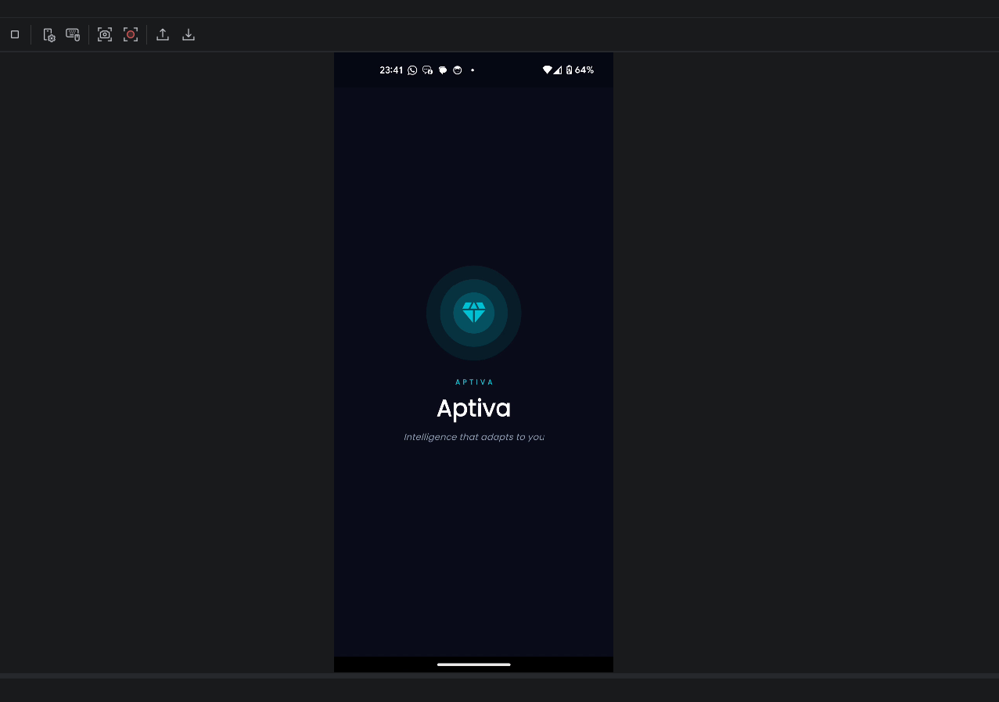

We initialy had our first wireframe but it was not to the vision of the app so it was changed to the image above. I mage of our initial wireframe is the one below.

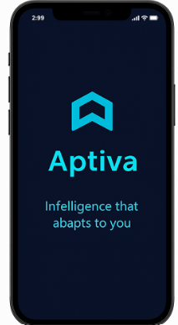

Login Screen
- Clean layout with email/password fields.
- Cyan “Sign In” button, Google sign-in option, register link.
- Subtle glow accents for modern appeal.
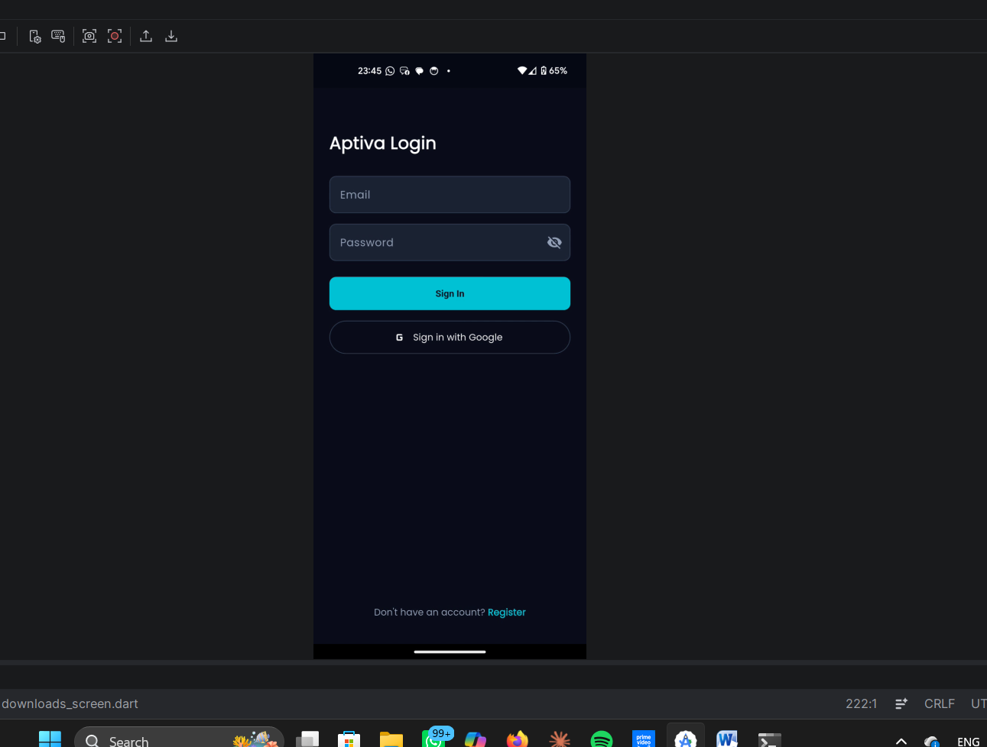

Dashboard
- Greeting header with persistent network badge (Excellent/Good/Poor/Offline).
- “Continue Learning” card with progress bar.
- Grid of enrolled courses with progress indicators.
- Bottom navigation bar with Home, Courses, Offline, Studio.

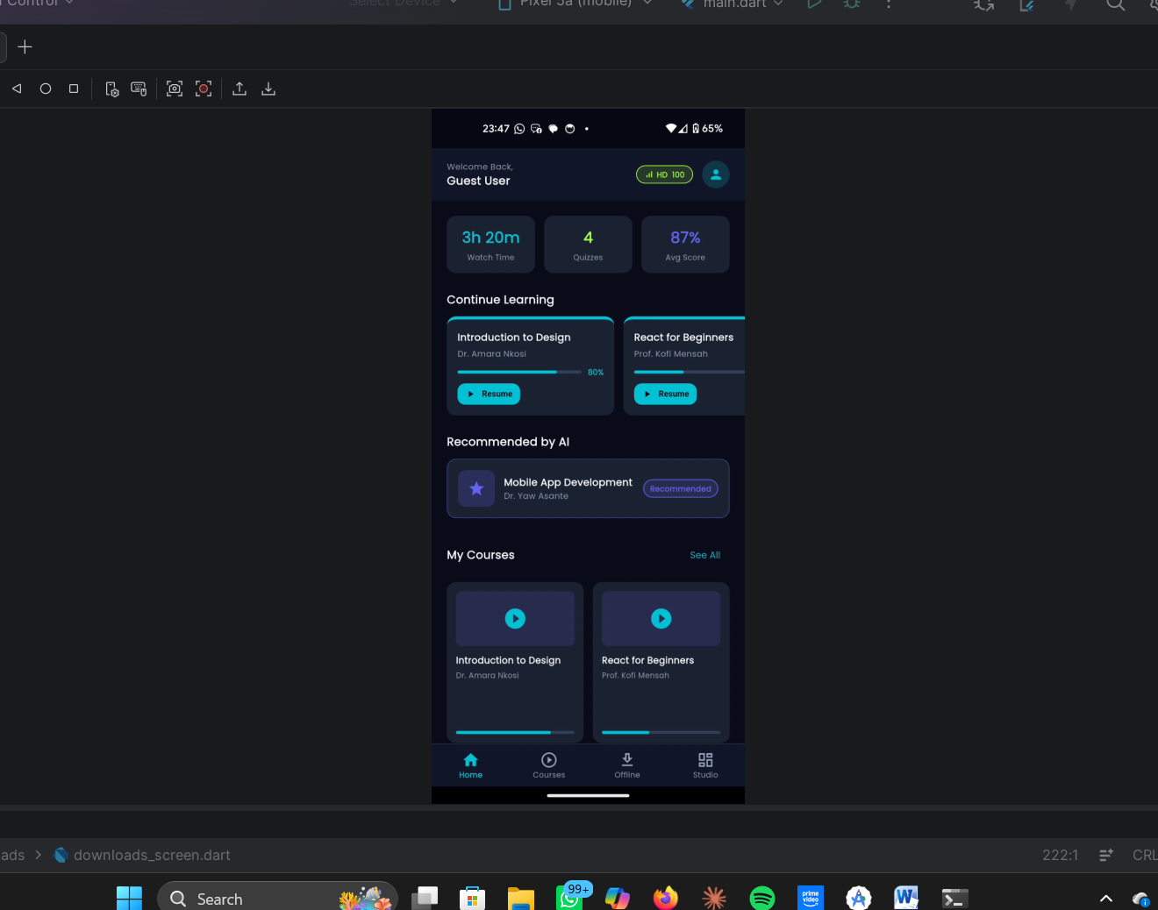

Video Player
- Adaptive quality badge (HD, SD, Audio-Only).
- Cyan scrubber bar with playback controls.
- Lecture list with active highlight.
- Take quiz option
- With an option to rate the course

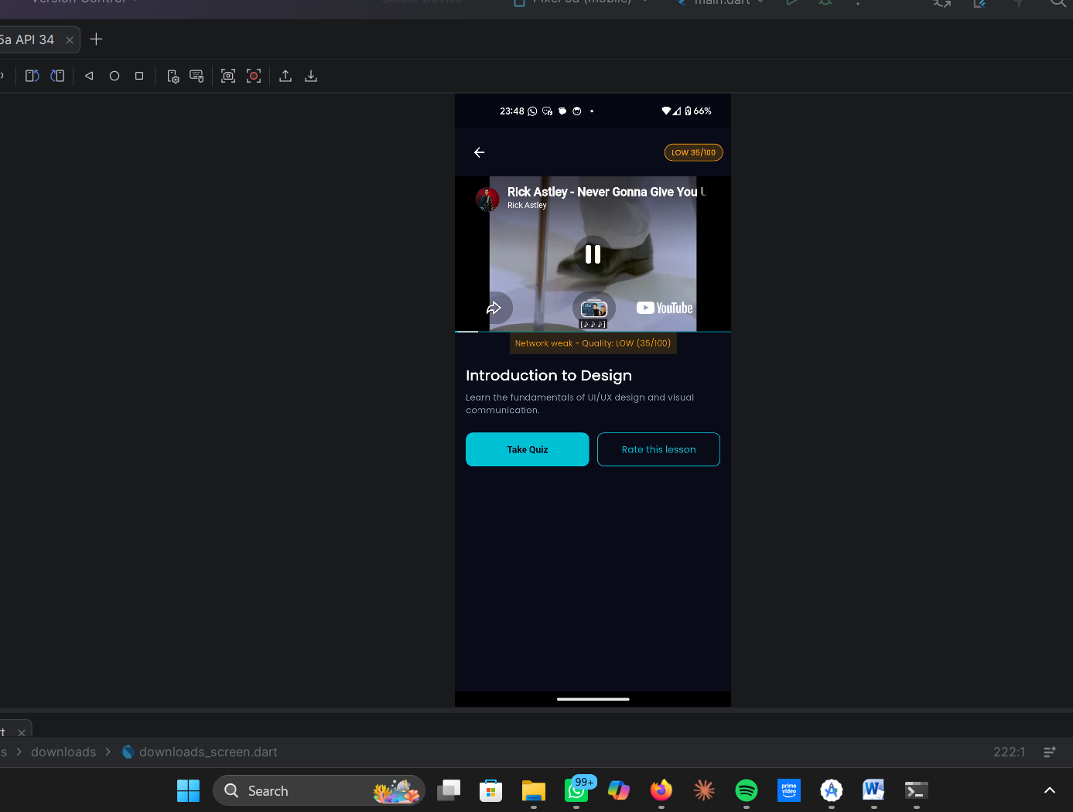
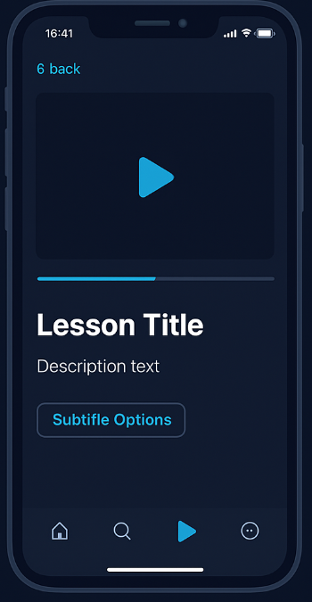

Audio-Only Mode
- Rose alert banner indicating low bandwidth.
- yellow audio visualizer with waveform animation.
- Resume button when bandwidth improves.

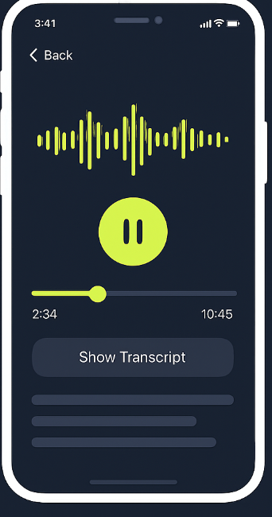

Offline Content
- Downloaded courses with cyan “Offline” badge.
- Storage bar showing usage.
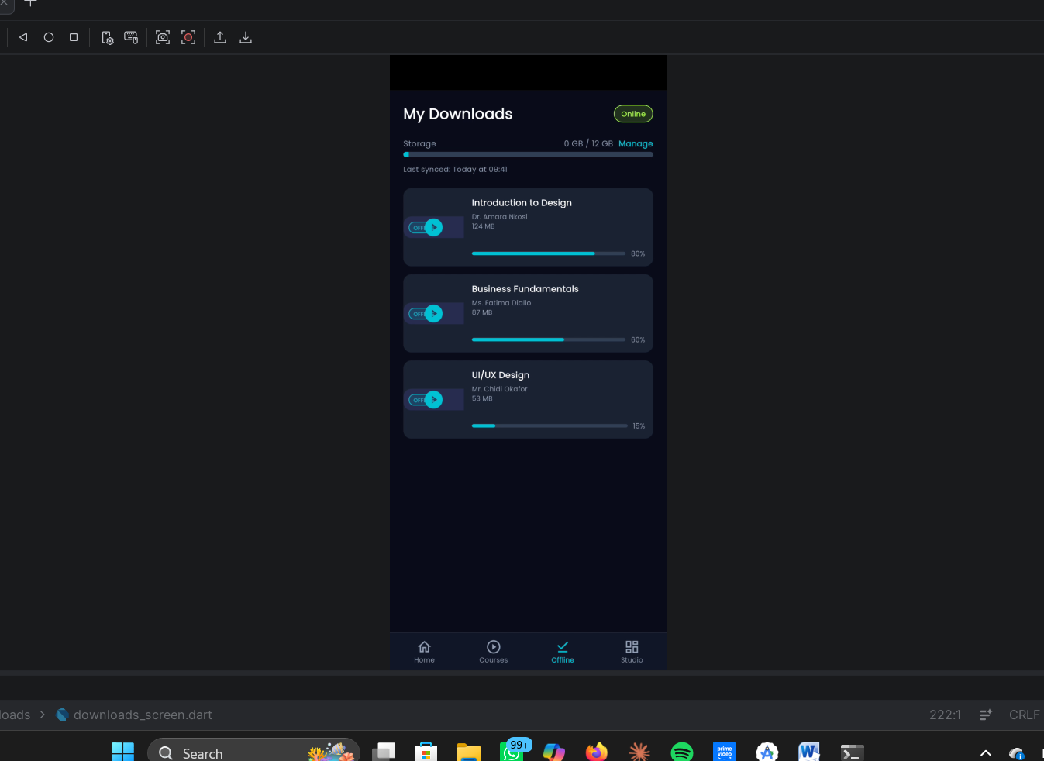
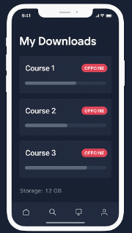

Quiz Screen
- Dark card with cyan accent bar.
- Multiple choice answers with cyan highlight for selection.
- Timer and progress bar for quiz tracking.
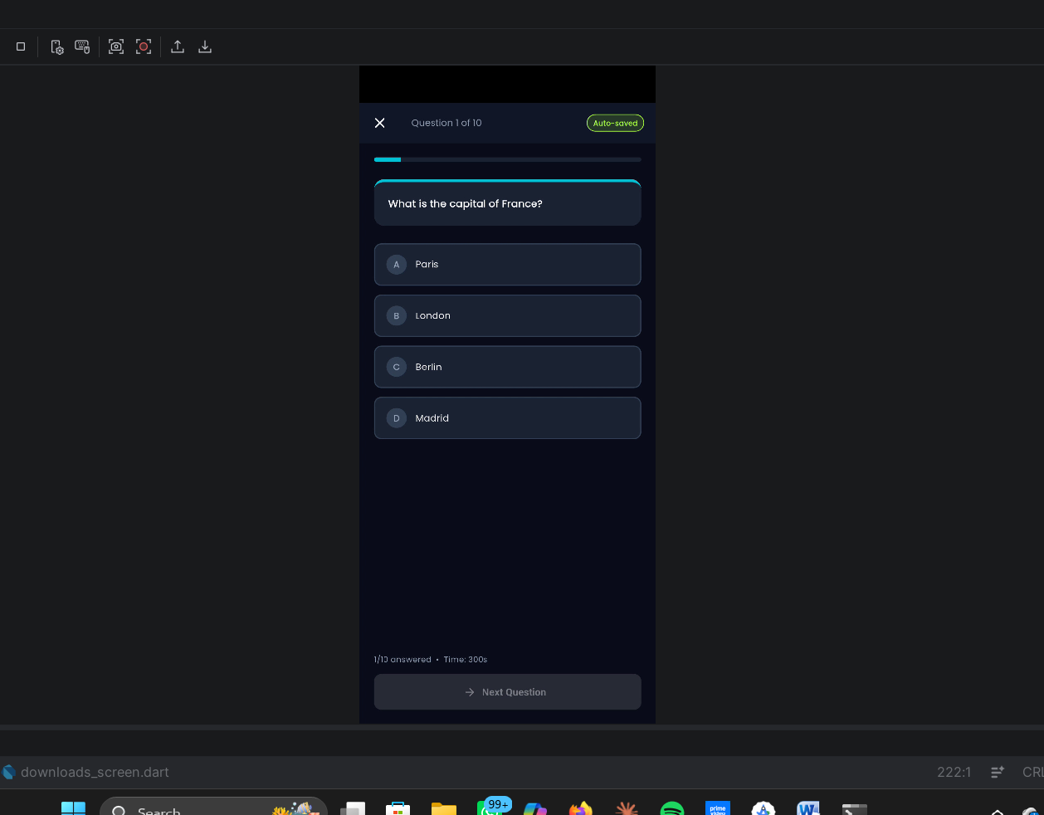

Instructor Dashboard & QoE Feedback
- Stats cards (students, courses, average score).
- Alerts for students below 30% completion.
- Feedback screen with star ratings, sliders, and comment box.
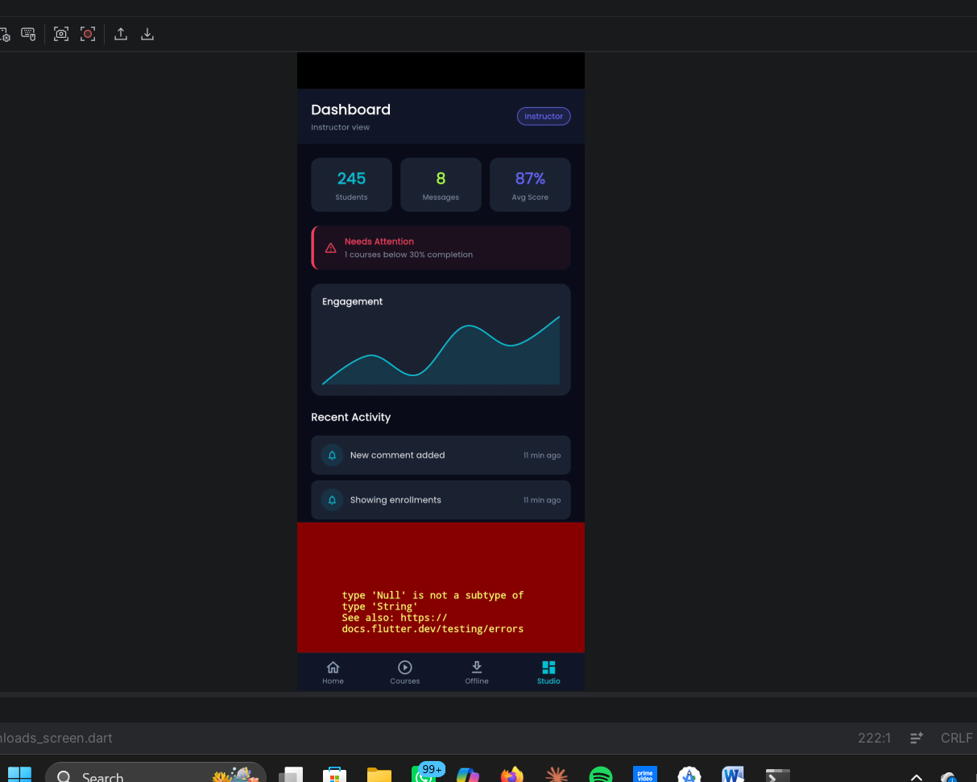

  - 5. Accessibility and Usability
Aptiva’s design is accessible by default:
- WCAG 2.1 AA compliance (minimum 4.5:1 contrast ratio).
- Touch targets: minimum 48dp for all interactive elements.
- Text size: minimum 12sp for readability.
- Progressive disclosure: information revealed on demand to avoid clutter.

  - C. Frontend Implementation
  - 1. Flutter Framework
Why Flutter? Flutter was chosen because it allows one codebase to run on Android, iOS, Web, and Desktop. This reduces development time and ensures consistency across platforms.
- Performance: Flutter uses the Skia rendering engine, which draws UI elements directly to the screen, avoiding the performance overhead of native bridges.
- Adaptability: Its reactive UI system makes it ideal for Aptiva’s adaptive features (switching between HD, SD, audio, offline).
- Integration: Flutter integrates easily with Firebase (authentication, messaging), SQLite (offline caching), and Agora (WebRTC live lectures).

  - 2. Clean Architecture
Why Clean Architecture? Clean Architecture separates the app into Presentation, Domain, and Data layers.
- Presentation Layer: Screens and widgets (e.g., dashboard_screen.dart) handle UI only.
- Domain Layer: Business logic and rules (e.g., quiz.dart) are independent of Flutter, making them testable.
- Data Layer: Handles APIs, repositories, and local storage (e.g., offline_cache_service.dart).
This separation ensures testability, scalability, and maintainability. If Firebase were replaced with another backend, only the Data layer changes the UI remains untouched.

  - 3. Folder Structure
Why this structure? Organizing files into screens/, widgets/, models/, and services/ ensures clarity.
- Screens: Each screen (Splash, Login, Dashboard, etc.) is isolated for readability.
- Widgets: Reusable components (buttons, cards, badges) prevent duplication.
- Models: Define data structures (User, Course, Quiz).
- Services: Handle APIs, authentication, network monitoring, and offline caching.

  - 4. Dependencies
Each package was chosen for a specific reason:
- video_player + chewie: Provide adaptive video playback with controls (pause, scrub, fullscreen).
- connectivity_plus: Detects network type (WiFi/4G/3G/2G) so Aptiva can switch formats.
- sqflite + path_provider: Enable offline caching of courses in SQLite, ensuring continuity without internet.
- provider: Manages reactive state — when network quality changes, the UI updates instantly.
- dio: Robust HTTP client with interceptors for monitoring API calls and upload progress.
- cached_network_image: Efficiently loads and caches course thumbnails.
- shimmer: Provides skeleton loaders, avoiding blank screens during content fetch.
- lottie: Adds JSON animations (waveform, network icons) for adaptive feedback.
- flutter_secure_storage: Stores JWT tokens securely in device keychains.
- agora_rtc_engine: Enables live lectures via WebRTC with adaptive audio fallback.
- firebase_core + firebase_messaging: Handle authentication and push notifications.
- workmanager: Ensures background sync of offline actions (quiz answers, progress).
- go_router: Provides declarative navigation with deep linking support.
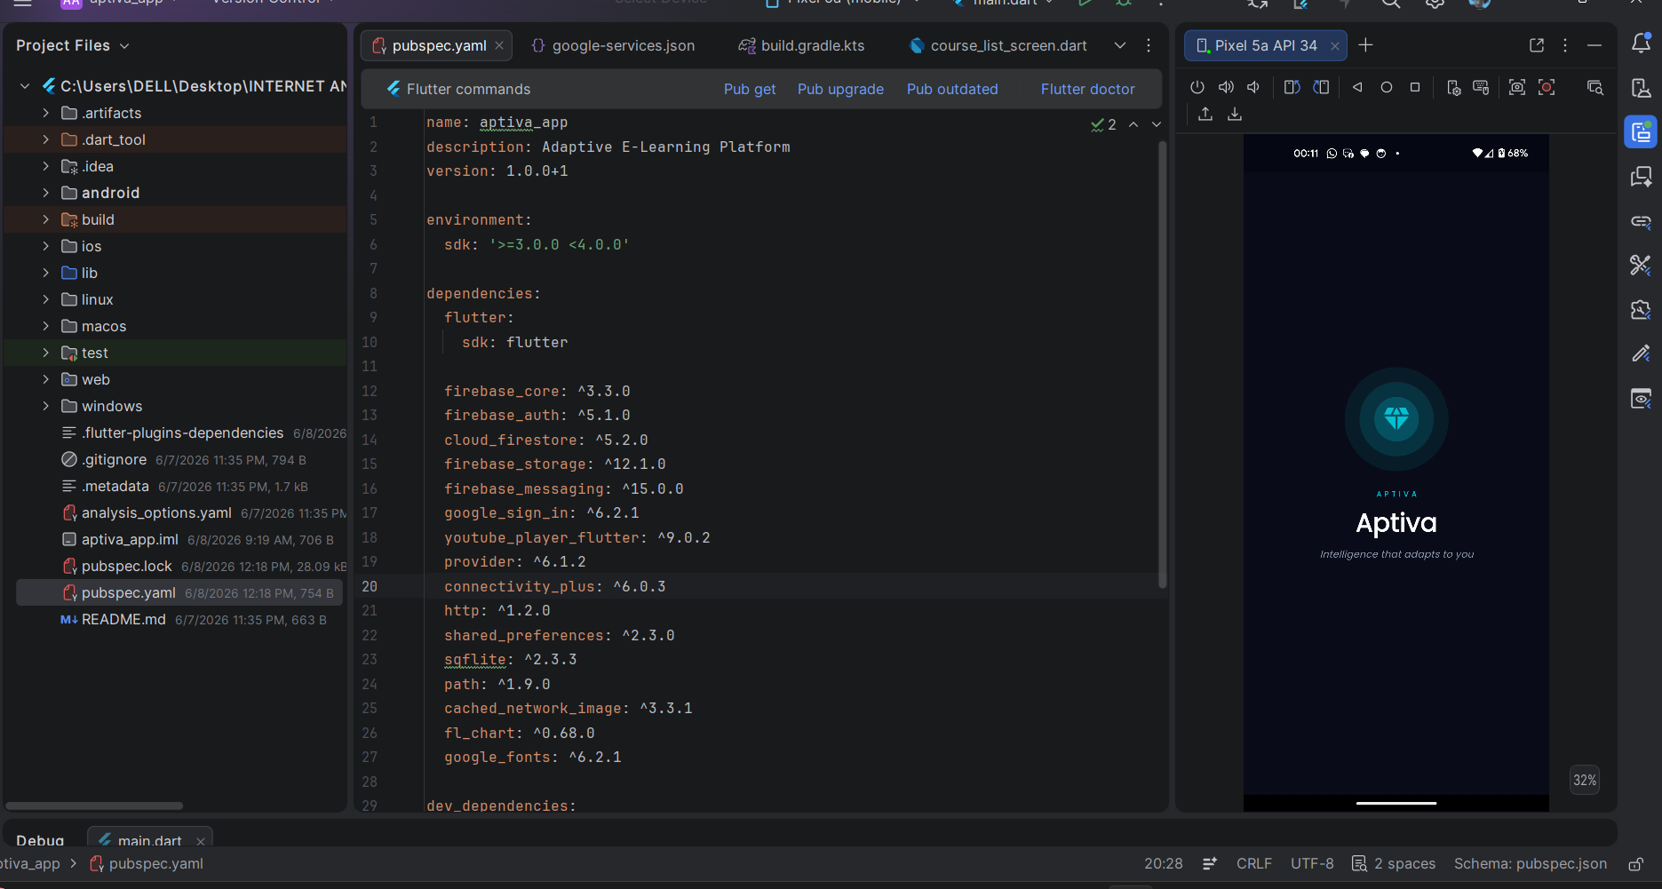

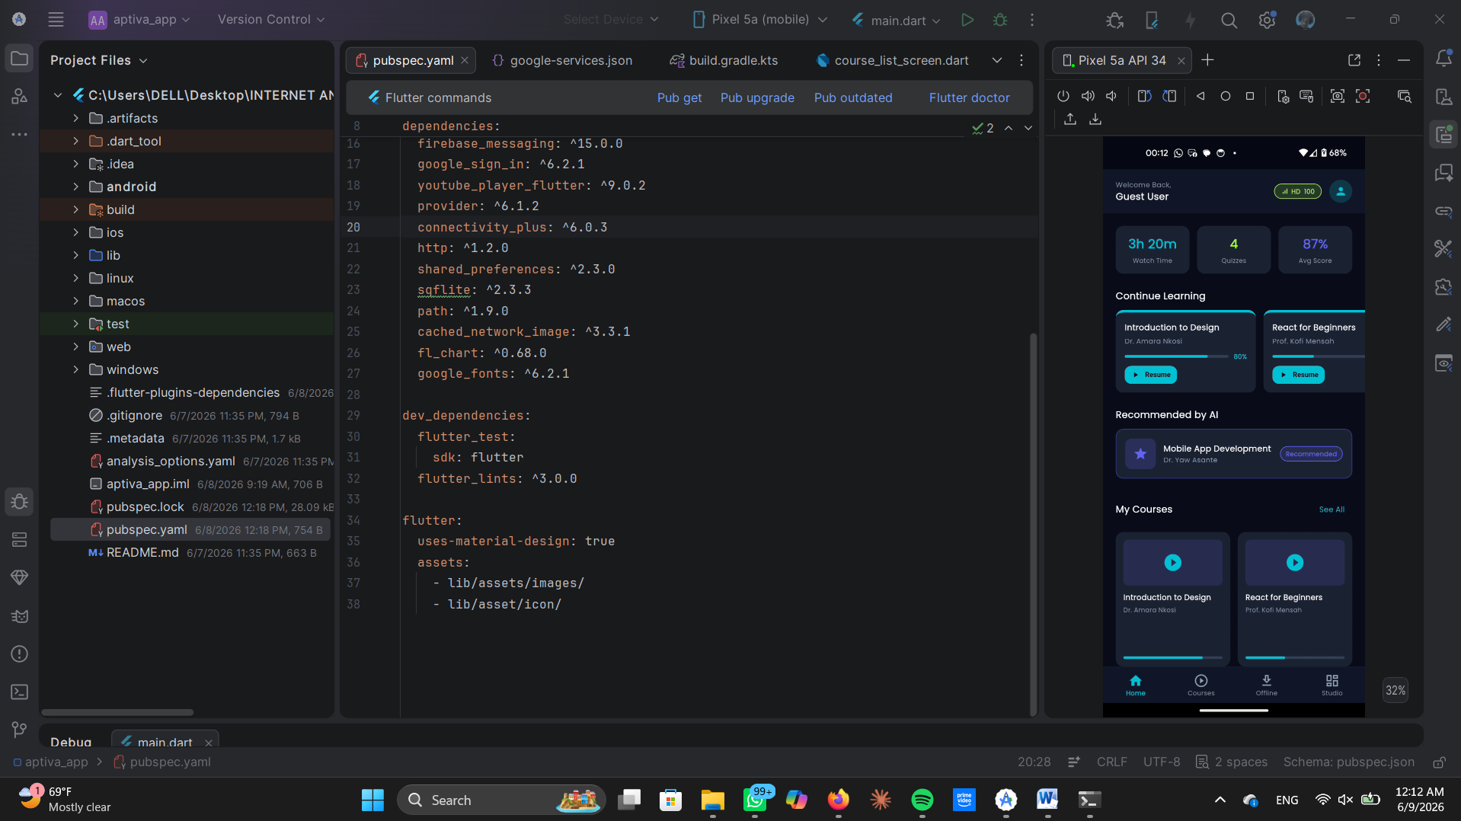
  - 5. Theme Management
Why centralize themes? All colors, fonts, and styles are defined in theme.dart. This prevents inconsistencies and enforces brand identity.
Example: AptivaColors.cyan is used everywhere for primary buttons.
Example: AptivaText.heading1 ensures consistent typography across screens.
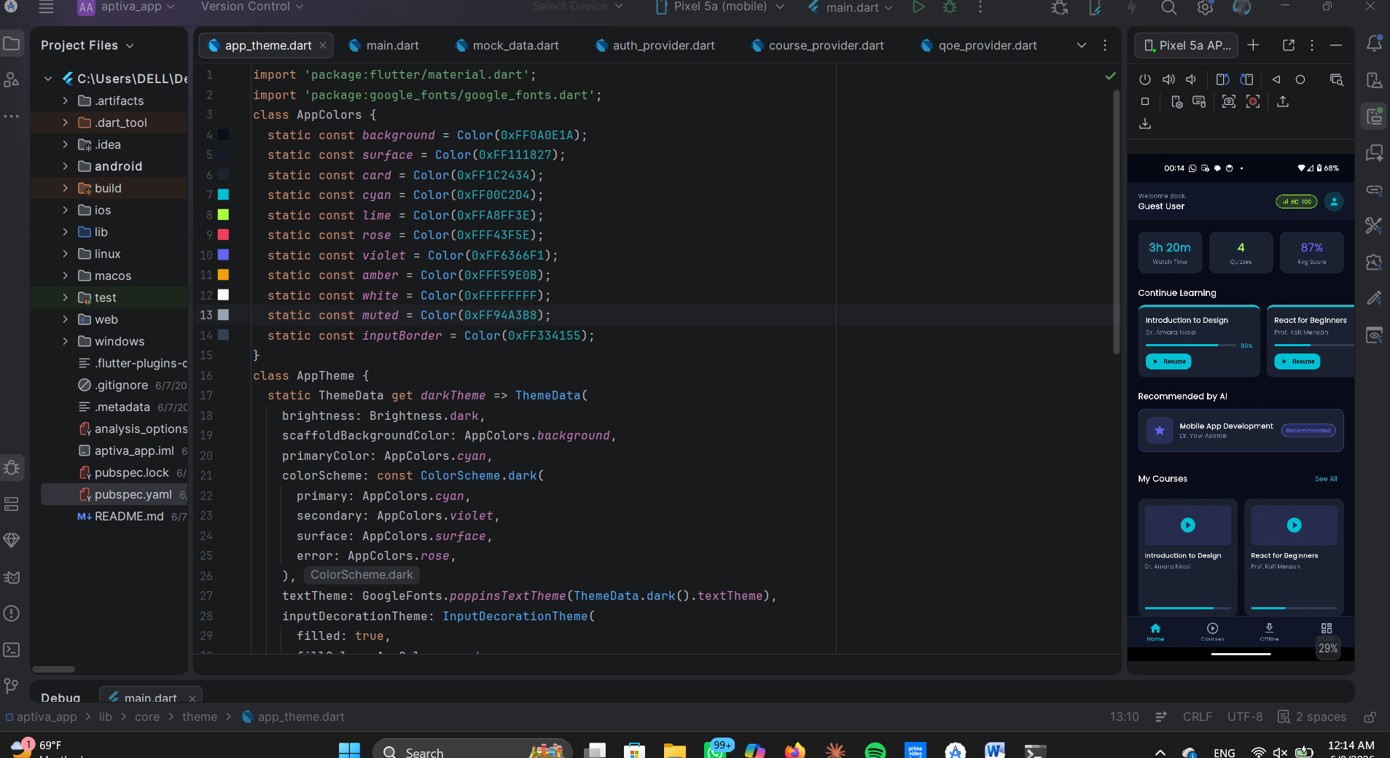

  - 6. Critical Widgets
Reusable widgets embody Aptiva’s adaptive philosophy:
- NetworkQualityBadge: Displays real-time connectivity status (Excellent, Good, Poor, Offline).
- AdaptivePlayer: Switches seamlessly between HD, SD, audio-only, and offline content.
- CourseCard: Shows course title, instructor, progress bar, and format badges.
- AudioWaveformWidget: Animated waveform reassures learners in audio-only mode.
- ShimmerCard: Skeleton loader improves perceived performance.
- AptivaButton: Ensures consistent button styling across the app.
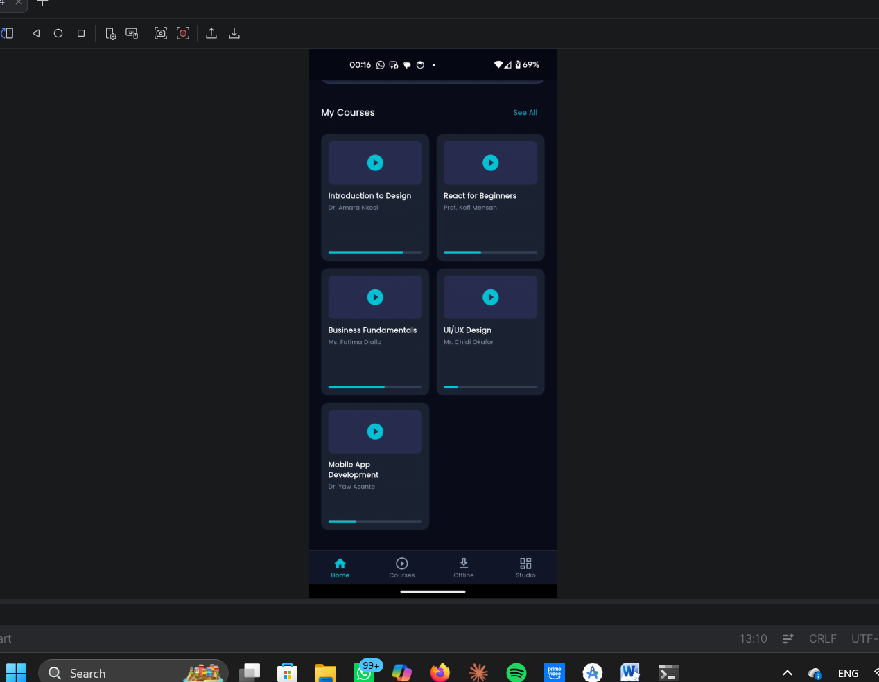


  - 7. Screens Implementation
Each screen was designed to embody adaptability:
- Splash Screen: Branding, tagline, loading animation.
- Login/Register: Secure authentication with Firebase, role selector.
- Dashboard: Courses grid, AI recommendations, persistent network badge.
- Video Player: Adaptive quality switching, lecture list, playback controls.
- Audio-Only Mode: Rose alert banner, waveform animation, resume option.
- Offline Content: Downloaded courses with storage bar and sync status.
- Quiz Screen: Offline-first quizzes with auto-save and sync.
- Instructor Dashboard: Analytics cards, alerts, upload button.
- QoE Feedback: Star ratings, sliders, comments, auto-tags.

  - 8. State Management
Why Provider? Provider allows reactive updates. For example:
If bandwidth drops, the NetworkQualityBadge changes instantly.
If a student answers a quiz offline, the state is saved locally and synced later.
If recommendations change, the dashboard updates dynamically.

  - 9. Security and Offline Continuity
- JWT tokens: Stored securely in flutter_secure_storage.
- Offline cache: Implemented with SQLite (offline_cache.db) for resilience.
- Background sync: Managed by workmanager, ensuring queued actions (quiz answers, progress, feedback) are flushed when connectivity is restored.
- Encryption: Offline cache encrypted with AES-256 for data protection.
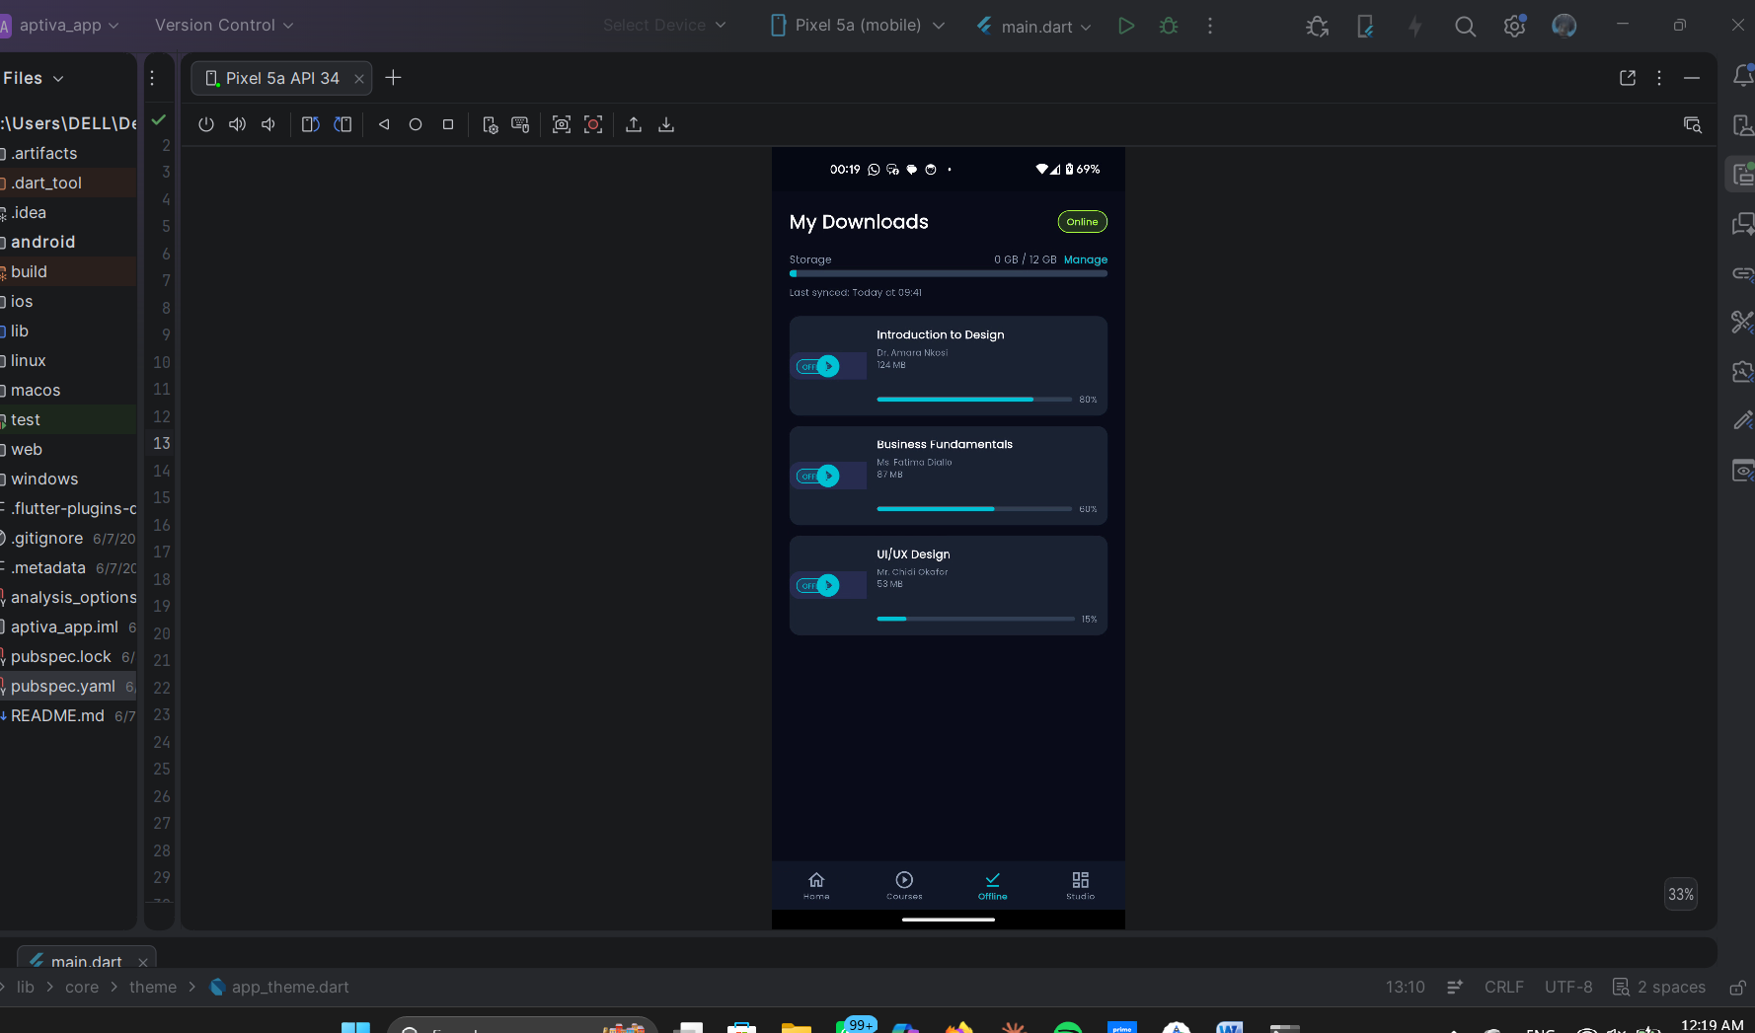

VI. Results

  - 1. Splash Screen
- Result: The splash screen immediately communicates Aptiva’s brand identity with the diamond icon, concentric glow circles, and tagline “Intelligence that adapts to you.”
- Why it matters: It sets the tone of adaptability and intelligence from the very first interaction. The loading animation reassures users that the system is responsive, even on low-end devices.

  - 2. Login/Register Flow
- Result: Secure authentication with Firebase, role selector (Student/Instructor), and Google sign-in option.
- Why it matters: Ensures inclusivity by supporting multiple login methods, while role-based access control guarantees that students and instructors see only relevant features. The clean UI reduces cognitive load, making it accessible even for first-time users.

  - 3. Dashboard
- Result: Displays enrolled courses, progress bars, AI recommendations, and persistent network quality badge.
- Why it matters: The dashboard is the learner’s control center. The persistent badge ensures transparency about connectivity, while adaptive recommendations personalize the learning journey. Progress indicators motivate learners by showing tangible achievement.

  - 4. Video Player
- Result: Adaptive playback with quality badges (HD, SD, Audio-Only), scrubber, and lecture list.
- Why it matters: This validates Aptiva’s core promise seamless adaptation to bandwidth conditions. Learners never face interruptions; instead, the system gracefully downgrades or upgrades quality. The lecture list ensures continuity and easy navigation.

  - 5. Audio-Only Mode
- Result: Activates automatically under poor bandwidth, with rose alert banner and animated waveform.
- Why it matters: This feature transforms a potential failure (loss of video) into a positive adaptive experience. The waveform reassures learners that content is still being delivered. The resume option empowers them to return to video when bandwidth improves.

  - 6. Offline Content
- Result: Courses can be downloaded, stored locally, and accessed without internet. Sync status shows when content is updated.
- Why it matters: Offline continuity is critical in low-resource settings. Aptiva ensures that learning does not stop when connectivity fails. This validates the requirement for resilience and inclusivity.

  - 7. Quiz Screen
- Result: Offline-first quizzes with auto-save every 30 seconds, progress bar, and timer.
- Why it matters: Learners can attempt assessments without internet, and results sync automatically when connectivity is restored. This proves Aptiva’s ability to support academic rigor even in constrained environments.

  - 8. Instructor Dashboard
- Result: Displays analytics (student progress, quiz scores, completion rates), alerts for students below 30%, and upload options.
- Why it matters: Instructors gain actionable insights into learner performance. The rose alert badge highlights struggling students, enabling targeted interventions. This validates Aptiva’s role in supporting not just learners, but educators.

  - 9. QoE Feedback
- Result: Collects star ratings, slider scores, comments, and auto-tags (e.g., “Offline mode used”).
- Why it matters: Feedback loops recalibrate the adaptive engine, ensuring Aptiva evolves with real learner experiences. This demonstrates intelligence beyond static delivery — Aptiva learns from its users.

  - Overall Impact
The results confirm that Aptiva’s frontend implementation is not just functional, but adaptive, inclusive, and academically defensible. Each screen validates a requirement:
- Splash → Identity.
- Login/Register → Security & inclusivity.
- Dashboard → Personalization.
- Video Player → Adaptivity.
- Audio-Only → Resilience.
- Offline Content → Continuity.
- Quiz → Academic rigor.
- Instructor Dashboard → Analytics.
- QoE Feedback → Intelligence.
Together, these results prove Aptiva’s mission: “Intelligence that adapts to you.”

VII. Conclusion
The development of Aptiva’s frontend demonstrates how adaptive intelligence can be translated into a tangible, user-friendly interface. From the splash screen to the instructor dashboard, every design choice was rooted in the requirements defined in the SRS and the architectural models established earlier.
- Identity: The updated Aptiva icon and brand system communicate adaptability, intelligence, and inclusivity. This ensures that learners immediately recognize Aptiva as a platform designed for them, regardless of their connectivity constraints.
- Visual Design: The dark-first palette, neon accents, and carefully chosen typography balance modern aesthetics with accessibility. These decisions reduce battery consumption, improve readability on low-end devices, and comply with WCAG 2.1 AA standards.
- Frontend Implementation: By adopting Flutter with Clean Architecture, Aptiva achieves cross-platform reach, modularity, and maintainability. The use of Provider for state management ensures real-time responsiveness, while SQLite and WorkManager guarantee offline continuity and background synchronization. Each dependency — from video_player to firebase_messaging — was selected to solve a specific problem, making the system robust and academically defensible.
- Results: The implemented screens validate Aptiva’s mission. The splash screen establishes identity, the dashboard personalizes learning, the video player adapts to bandwidth, the audio-only mode ensures resilience, offline content guarantees continuity, quizzes maintain academic rigor, and instructor dashboards provide actionable analytics. QoE feedback closes the loop, allowing Aptiva to evolve based on learner experiences.
In summary, Task 5 proves that Aptiva is not just an e-learning app, but a comprehensive adaptive learning intelligence. It bridges the gap between technical sophistication and user accessibility, ensuring that education remains inclusive even in low-resource environments. Aptiva’s UI design and implementation embody its tagline: “Intelligence that adapts to you.”

VIII. References
- IEEE Std 830-1998: Recommended Practice for Software Requirements Specifications.
- Pressman, R.S. Software Engineering: A Practitioner’s Approach.
- Sommerville, I. Software Engineering, 10th Ed.
- Flutter Documentation.
- Agora WebRTC SDK.

